**HL7 PDDI-CDS WG Meeting 02/20/2019**

**In Attendance: Richard Boyce, Thomas Reese, Howard Strasberg, Dan Malone, Sam Habiel, Joao Bosco Jares**

Agenda and minutes:

- Follow up from discussion with the CDS WG and CDS Hooks folks (order-select and order-sign)

Tom discussed the results of the discussion and introduced the order-select, order-sign, and order-modify hooks. Discuss followed about order-modify and how it is different from “order accept” which is present in VA Vista. Rich proposed that we focus our efforts for the next version of the IG on order-select and order-sign and postpone detailed discussion of any possible hooks between the two for after the next IG version is commented for ballot and discussed at the September Connectathon. After some discussion, this was agreed by all in attendance.

Howard shared the following screenshots of the context components of the new hooks and we discussed the purpose of the ‘selections’ and ‘draftOrder’ properties.

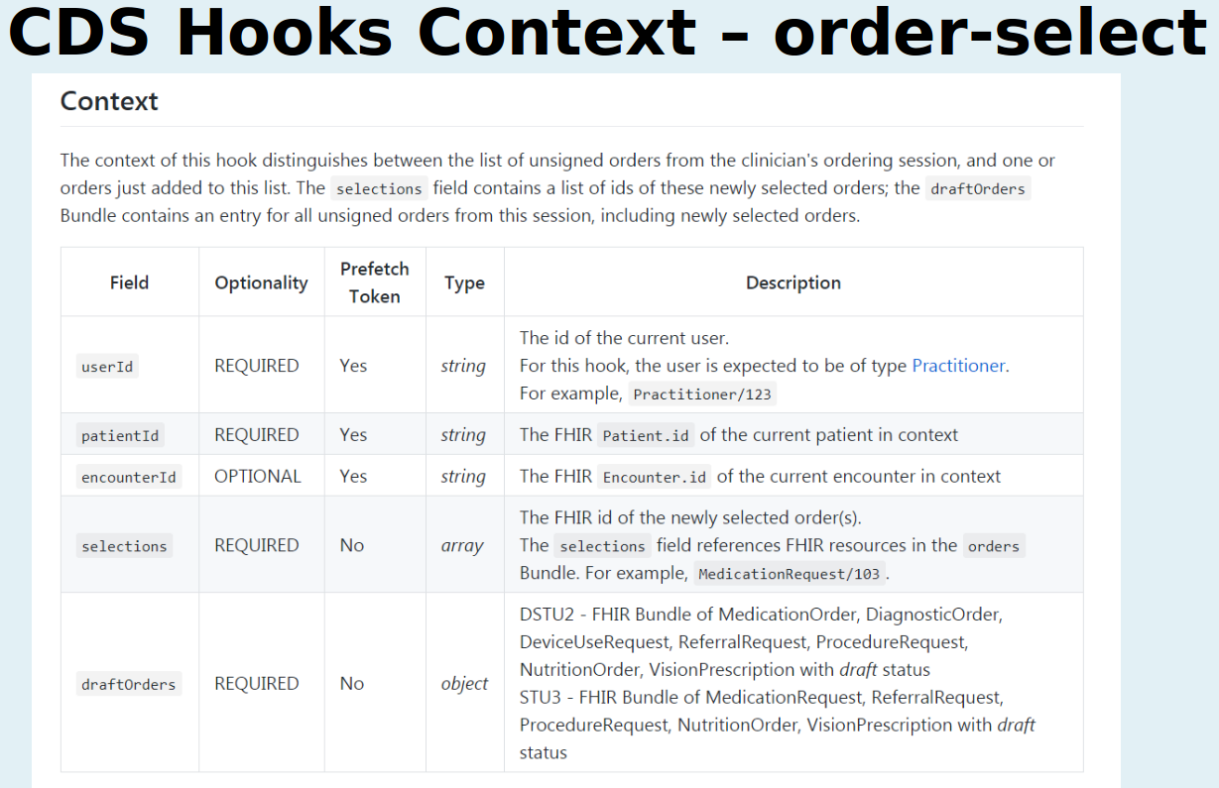

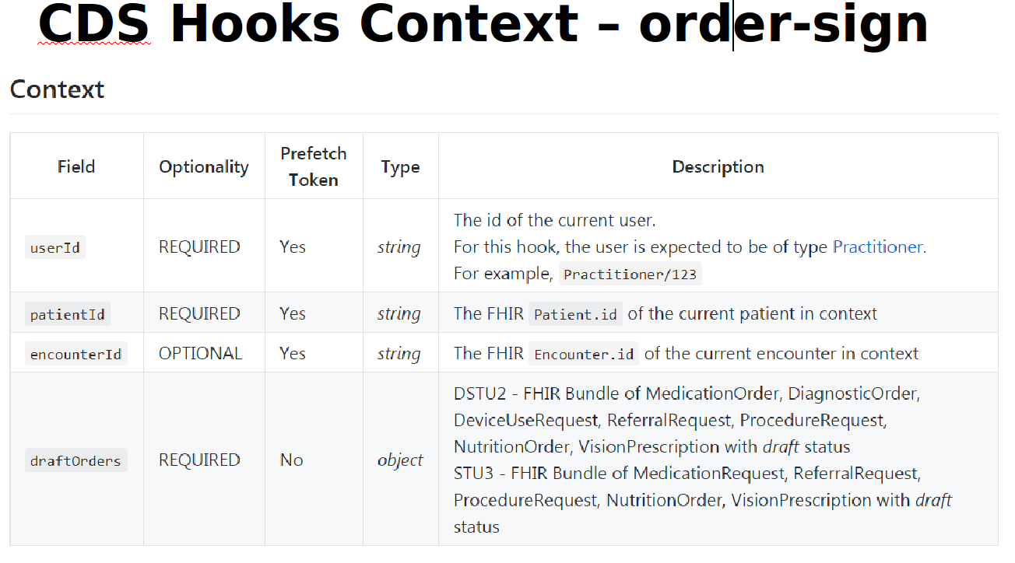

- Planning for the September WG meeting: identify paperwork requirements, set milestones and timeline

– CDS Engine – we discussed that the current version of CQF-Ruler working with R4 will be modified to implement the IG recommendations. We will need access to a new branch of the project so we can port in last years work with R4 and the new hooks, and start implementing order-select. Rich will ensure that an engine that accepts DSTU2/STU3 is working for the fall connectathon in case any group wants to test order-select or order-sign PDDI Hooks.

- Passing back a resource such as DetectedIssue or RiskAssessment in the response: Not discussed

- Referencing drug-drug pair (i.e., context and prefetch) in DetectedIssue resource: Not discussed

- There is a mitigation element but no potentiation element: Not discussed

**Action steps:**

- Rich and Joao - will work on obtaining a branch of the main Cqf-ruler for this project and make progress on porting the old resources to R4 and updating the CQL workflow to run using order-sign requests. Specify the changes needed to implement order-select.

- Tom – work on drafting resources that show various options DetectedIssue and RiskAssessment, referencing drug-drug parin in the DetectedIssue

- Rich will update the IG to use the two new hooks throughout the paperwork

**Next Call:**

March 6th at 11am Eastern US timeline

General Use

Please join my meeting from your computer, tablet or smartphone.

https://global.gotomeeting.com/join/513111949

You can also dial in using your phone.

United States: +1 (571) 317-3129

Access Code: 513-111-949

More phone numbers

Germany: +49 692 5736 7317